Annex B

Media Profiles – HR Tech Transformation Programme (HRTTP)

- Fei Siong Food Management

- Fei Siong Food Management, one of Singapore’s leading food establishments, implemented ArcLab technology to create and deliver mobile bite-sized, bi-lingual learning modules for employees.
- With the accessibility of the mobile learning platform, employees are now able to learn on the go, significantly improving their learning experience. This mode of training delivery also empowers staff to take ownership of their own development.
- With the automation of administrative work like sending of reminders and the tracking of modules completion by each employee, the Learning and Development (L&D) team can now focus on analysing training quiz scores to evaluate the effectiveness of the modules.
- The tech solution helped Fei Siong's L&D Team save 50 percent of the time spent on developing and delivering training modules by reducing manual training and administrative tasks.
- With ArcLab, Fei Siong have successfully rolled out COVID-related SOPs, e.g. Self-Swab Test for F&B outlets – an ArcLab module with videos was created to teach their staff how to administer the swabbing.

  Mervin Lee (李镇元), 36,  Vice President, Corporate Development Group  Language proficiency: English, Mandarin | As the Vice President (VP) of Fei Siong Group, Mervin is responsible for governance of group policies and procedures, aligning and integration of business activities with overall strategy and mission, leading and motivating staff to advance employee engagement goals.  He is committed to upskilling employee digital literacy and believes that implementing it in the workplace is not only a fundamental component of operational excellence but also the building blocks of organisational success.  He led the implementation of the Enterprise Resource Planning (ERP) platform which is intended to digitalise the process of ordering and managing supplies and is the first organisational wide digitalisation project. Subsequently, he also sourced and implemented other transformation projects include a Human Resource Management System (HRMS) as well as a Learning Management System (LMS). He believes that human capital is key to the sustainable growth for all enterprises and enjoys exploring new ideas to improve productivity through digitalisation.
Ms Toh Lay Lay (卓莉莉), 53, Outlet Staff  Language Proficiency: Mandarin  *Profile is not willing to be photographed | Lay Lay has been working as a storefront employee for over 20 years and is currently working at Nam Kee Pau at Bugis Junction as a Stall Assistant where her primary duties include cashiering and food preparation.  Over the past 12 years in the F&B line, she has never seen the need nor has been given the opportunity to receive training. This changed when she joined Fei Siong Group in June 2020, where learning and development is emphasised, especially for their customer-facing staff.  At Fei Siong group, L&D trainers traditionally waited for individual outlet staff to be available during non-peak times to deliver in-person training that might be disrupted by operations.  With the support of the HRTTP pilot programme, Fei Siong was able to create and deliver mobile bite-sized modules for employees through the ArcLab platform.  For Lay Lay, this increased the convenience of her learning, as she can assess the training materials and receive updates on-the-go on her mobile phone, allowing her to fully focus on ensuring the smooth operations of the shop. She also has the flexibility to go through the necessary training modules at her own free time, or during her break at work.  In addition, the bi-lingual modules on the platform was especially useful for Lay Lay as it catered for employees like her who was only conversant in Mandarin.  Having reaped the benefits of using new technological tools for her learning and development, she believes that other F&B front-liners should not be afraid to upskill themselves and embrace learning to help make their work easier.

- LS 2 Services

- LS 2 Services, one of Singapore’s leading cleaning and conservancy companies in Singapore, utilised Jot-form, a cost-effective online form creator, and the OneDrive cloud storage platform, to digitise its performance management and HR administrative processes.
- This reduced their reliance on hardcopy HR documents like appraisal and leave forms. This also improved employee experience as employees can now submit HR documents conveniently via their mobile devices.
- 60 percent of the time savings were channelled towards value-added tasks towards the performance management process. The HR Manager’s role was redesigned with enhanced performance data analysis responsibilities and is now better placed to identify and drive initiatives for employee development and performance.

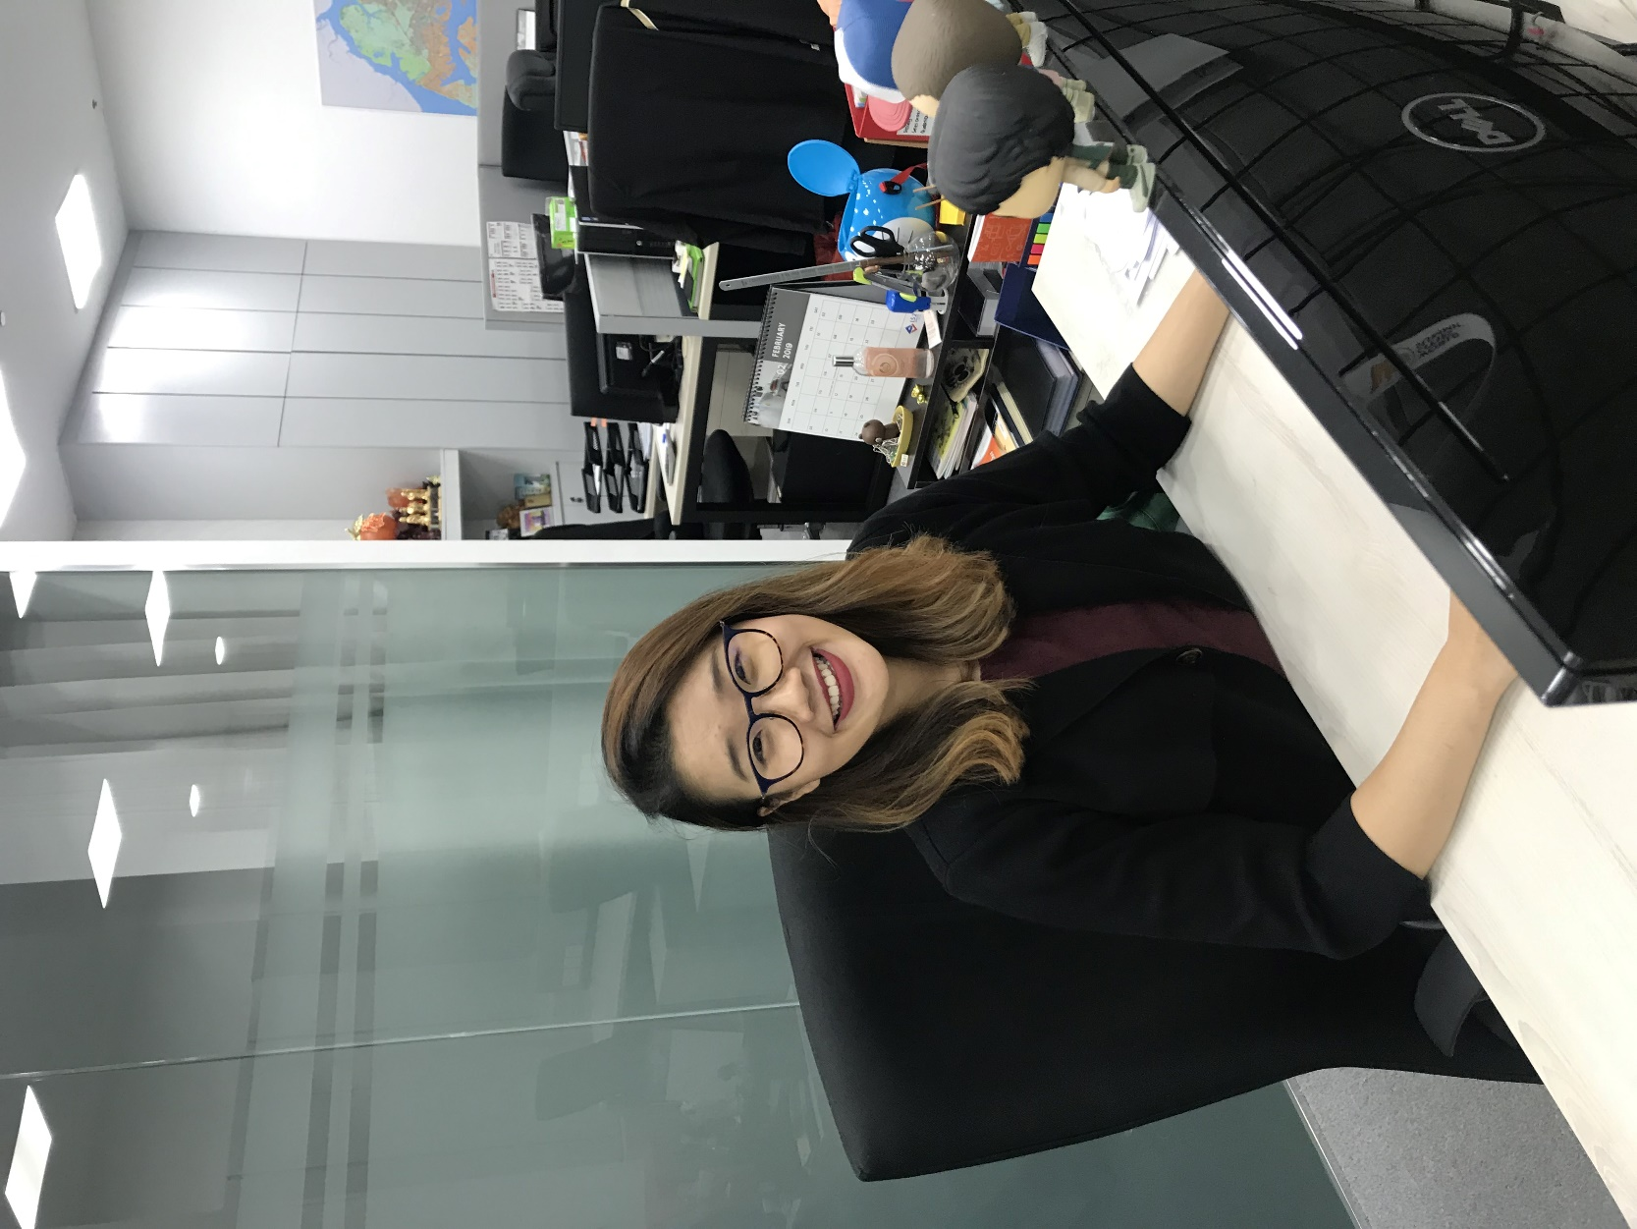  Tan Wei Ying 陈玮滢  Chief Operating Officer  Language proficiency: English and Chinese  *Filming allowed in LS2’s office | As the Chief Operating Officer at LS 2 Services Pte Ltd, Wei Ying is responsible for strategic ideations, tender drafting and translating of the company goals and plans into specific objectives and activities, driving growth with innovations.  Supervising and liaising with the different departments, she identifies opportunities to ensure and improve efficiency and productivity at LS 2 Services Pte Ltd. Additionally, she handles all escalated service issues, as well as maintains good relationships with key stakeholders.
  Ms Nancy Ting (陈淑芳)  64, HR Manager  Language Proficiency: English and Mandarin (basic) | Nancy has been working in the HR line for over 40 years across various sectors, including printing, logistics, defence, steel recycling and facilities management. Throughout her HR career, tasks were carried out manually, such as scanning and filing hard copy documents, chasing managers for persistent delays of timesheet submissions, and printing individual payslips and increment letters.  The HRTTP pilot programme exposed her to new technological tools for the first time in her HR career, which reduced manual workload, such as payroll matters. The digitalisation of HR processes allowed her to focus on value-added tasks.  Appraisals, which is now on digital platform, has allowed for faster and easier administration and completion. The time saved in the Performance Management process allowed Nancy to be more effective in communicating performance management programmes and policies to the employees. She could also monitor and evaluate the effectiveness of the performance management system by analysing data and feedback and to develop improvement actions.  Additionally, she is able to analyse the data collated on the JotForm platform to derive insights within and across teams to drive initiatives for employee development and performance.  Today, Nancy has plans to progress to be an HR Director and believes that the importance of continuous reskilling and using digital tools to augment their workflow will be the way forward for HR professionals.

